Activity: Managing Authorization

**Task 1. Check file and directory details**

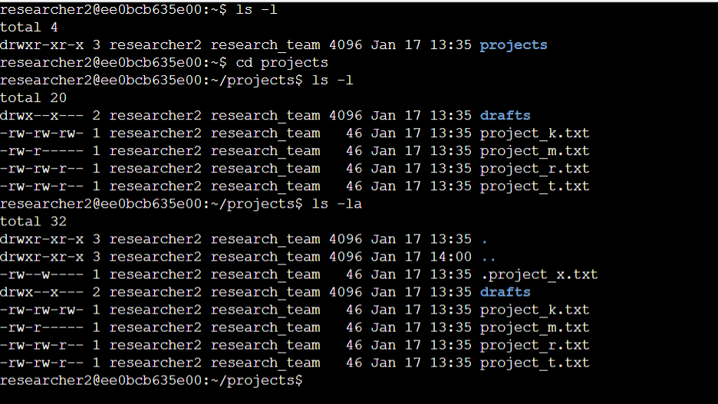

**Task 2. Change file permissions**

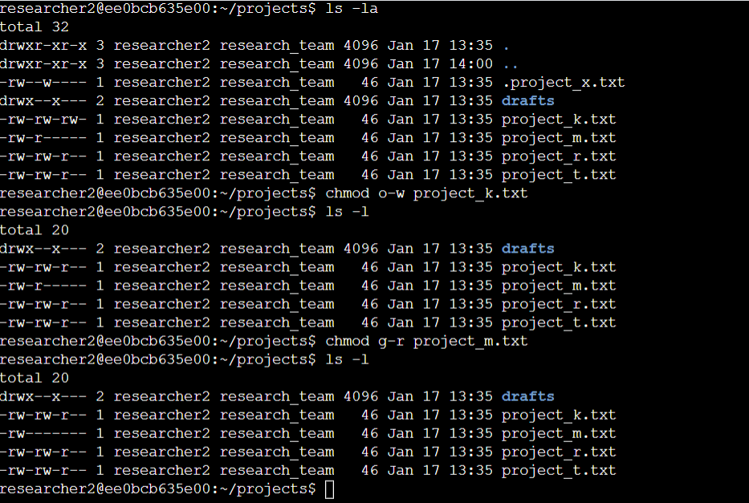

**Task 3. Change file permissions on a hidden file**

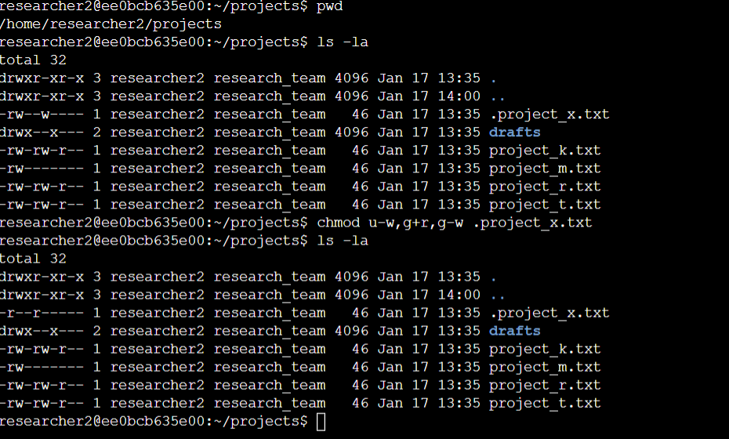

**Task 4. Change directory permissions**

